 | 12.1.46 Editors - Geometry Nodes Editor - Header - Add Menu - Utilities - Vector
Table of content
Detailed table of content 1
Add menu - Vector 4
Combine XYZ 4
Map Range 4
Mix Vector 5
Separate XYZ 6
Radial Tiling 7
Vector Curves 8
Vector Math 10
Vector Rotate 11

Detailed table of content
Detailed table of content
Detailed table of content 1
Add menu - Vector 4
Combine XYZ 4
Input 4
X Y and Z 4
Output 4
Color 4
Map Range 4
Input 4
From Min 4
From Max 4
To Min 4
To Min 5
Properties 5
Data Type 5
Interpolation Type 5
Clamp 5
Outputs 5
Vector 5
Mix Vector 5
Input 5
Factor 5
A 6
B 6
Properties 6
Data Type 6
Factor Mode 6
Output 6
Result 6
Separate XYZ 6
Input 6
Vector 6
Output 6
X, Y and Z 6
Radial Tiling 7
Input 7
Vector 7
Sides 7
Roundness 7
Properties 7
Normalize 7
Output 7
Segment Coordinates 7
Segment ID 7
Segment Width 7
Segment Rotation 7
Vector Curves 8
Inputs 8
Factor 8
Vector 8
Properties 8
Channel 8
X Y Z 8
Curve edit field 8
Selecting Points 8
Adding Points 8
Navigation elements 8
Zoom in and out 9
Clipping 9
Tools 9
Reset View 9
Extend horizontal 9
Extend extrapolated 9
Reset Curve 9
Vector Handle 9
Auto Handle 9
Auto Clamped Handle 9
X Y values 9
Delete Points 9
Outputs 9
Vector 9
Vector Math 10
Inputs 10
Vector 10
Vector 10
Scale 10
Properties 10
Operation 10
Outputs 10
Vector 10
Value 10
Vector Rotate 11
Inputs 11
Vector 11
Center 11
Axis 11
Angle 11
Properties 11
Type 11
Outputs 11
Vector 11

Add menu - Vector
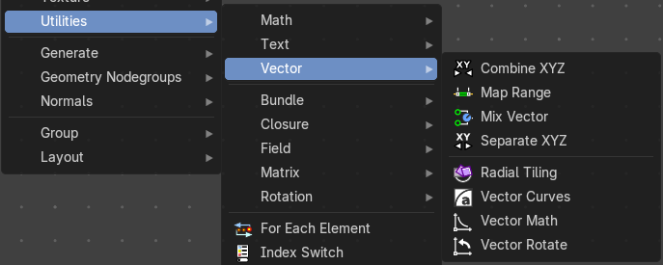
Vector nodes are for calculating vector operations.

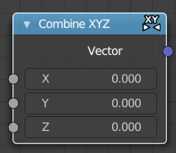
Combine XYZ
The Combine XYZ Node combines a vector from its individual components.

Input

X Y and Z
X, Y and Z values.

Output

Color
Color output.

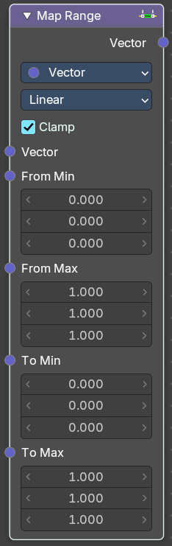
Map Range
Remap a value from a range to a target range.

Input

From Min
Vector 3 from the minimum input.

From Max
Vector 3 from the maximum input.

To Min
Vector 3 to the minimum input.

To Min
Vector 3 to the maximum input.

Properties

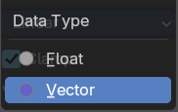
Data Type
What data to calculate.

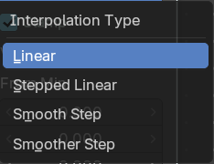
Interpolation Type
The interpolation method for the operation.

Clamp
Clamp the result to the target range of To Min - To Max.

Outputs

Vector
The output vector.

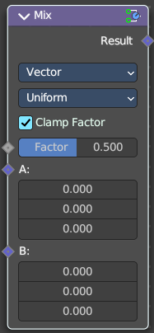
Mix Vector
Allows to mix values and vectors in various ways. The node has three different modes. Float, Vector and Color. This here is the node in Vector mode.

Input

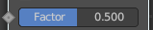
Factor
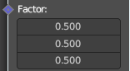
The mix factor. With mode Uniform it is a single value. With mode Non Uniform it is a vector.

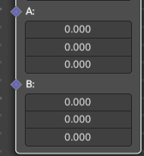
A
Vector A input.

B
Vector B input.

Properties

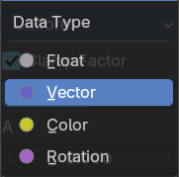
Data Type
Which mode to use. We cover here the Vector mode.

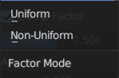
Factor Mode
Use a single value or a vector for the factor.

Output

Result
The output value or vector.

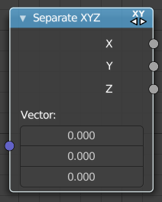
Separate XYZ
The Separate XYZ Node splits a vector into its individual components.

Input

Vector
The Input vector.

Output

X, Y and Z
The output vectors for X, Y and Z.

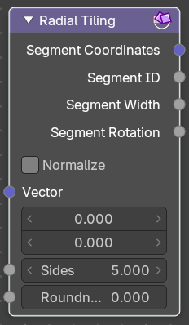
Radial Tiling
The Separate XYZ Node splits a vector into its individual components.

Input

Vector
The Input vector.

Sides
Number of angluar segments for tiling.

Roundness
Roundness of the segments coordinate systems.

Properties

Normalize
Stretch the textures to fit into each angular segment.

Output

Segment Coordinates
The segment coordinates for texture mapping.

Segment ID
Unique ID for every segment.

Segment Width
The width of every segment.

Segment Rotation
The rotation of every segment.

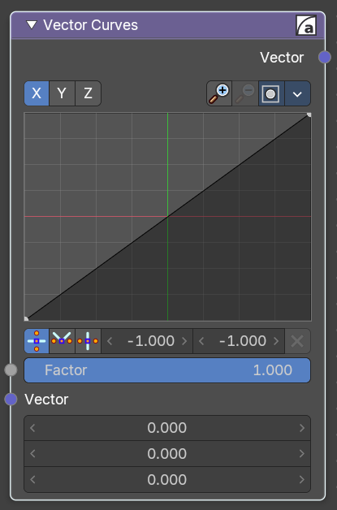
Vector Curves
The Vector Curves node maps an input vector components to a curve.

Inputs

Factor
Standard vector input.

Vector
Standard vector input.

Properties

Channel

X Y Z
X, Y, Z Channel buttons. Clicking on one of the channels displays the curve for each.

Curve edit field
Create and tweak a Bezier curve that varies the input levels (X axis) to produce an output level (Y axis).


Selecting Points
You can select curve points. This reveals two edit boxes for the x and y coordinate of this point.
Selected points can be moved around. Left click at them, hold the mouse button down and move them to a new location.


Adding Points
You can add new curve points by simply left clicking at the curve. Move the mouse to position them where you need it.

Navigation elements
The navigation elements at the top are described from left to right.

Zoom in and out
The two buttons with the magnifying glass at it zooms in and out in the curve window.

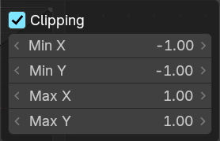
Clipping
Clipping options. Set up clipping for the stroke.

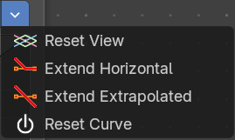
Tools
Tools is a menu where you can find some curve related tools.

Reset View
Resets the curve windows zoom.

Extend horizontal
Extends the curve before the first curve point and behind the last curve point horizontally.

Extend extrapolated
Extends the curve before the first curve point and behind the last curve point extrapolated.

Reset Curve
Resets the curve to the initial shape.

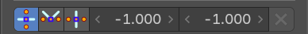
Vector Handle
Set handle type to Vector.

Auto Handle
Set handle type to Auto.

Auto Clamped Handle
Set handle type to Auto Clamped.

X Y values
The x and y values of the selected curve point.

Delete Points
Deletes selected curve points.

Outputs

Vector
Standard vector output.

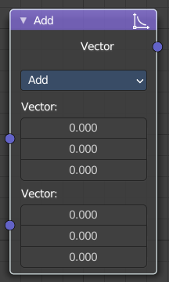
Vector Math
The Vector Math node performs the selected math operation on the input vectors.

Inputs
The inputs of the node are dynamic. Some inputs are only available in certain operations. For instance, the Scale input is only available in the Scale operator.

Vector
Input vector A.

Vector
Input vector B.

Scale
Input Scale.

Properties

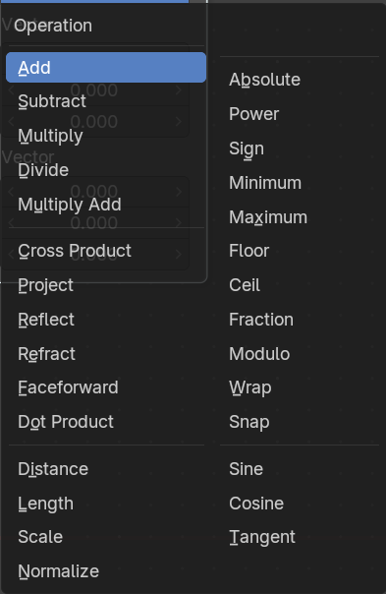
Operation
The vector math operator to be applied on the input vectors.

Outputs
The output of the node is dynamic. It is either a vector or a scalar depending on the operator. For instance, the Length operator have a scalar output while the Add operator have a vector output.

Vector
Output vector.

Value
Output value.

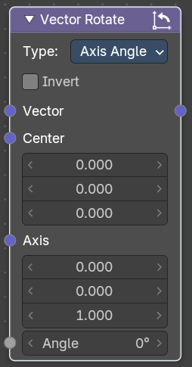
Vector Rotate
The Vector Rotate node allows rotations by a vector.

Inputs
The inputs of the node are dynamic. Some inputs are only available in certain operations. For instance, the Angle input is just available with the Axis Angle type.

Vector
Input vector.

Center
Input Center

Axis
Input Axis.

Angle
Input Angle

Properties

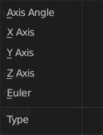
Type
The rotation type.

Outputs

Vector
The Output vector.

